PRN : 25070521137

Experiment 13
    - Fibonacci Sequence using Modules
Algorithm :

Main Program
      - Start
      - Input integer n
      - Check if n > 0
        - If Yes, go to Step 4
        - If No, go to Step 7
      - Call function generate_fibonacci_sequence(n)
      - Store result in fib_series
      - Print elements of fib_series separated by space
      - Display message: "Please enter a positive integer" (if n
≤ 0)
      - Stop

generate_fibonacci_sequence(max_value)

- Start
- If max_value < 0
- Return empty list []
- Initialize:
- seq = []
- a = 0, b = 1
- Repeat while a ≤ max_value
- Add a to seq
- Update values:
  - a = b
  - b = a + b
- Return seq
- Stop

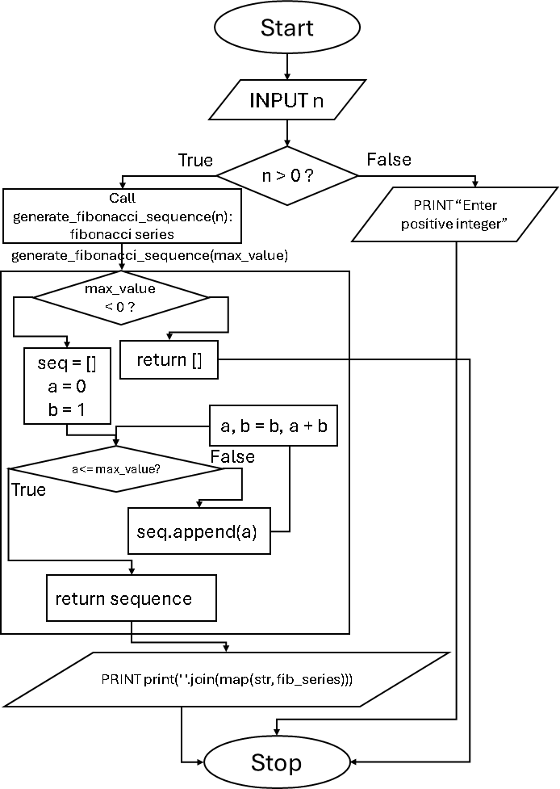
Flowchart :

Code :
main.py
import fibonacci_module n = int(input())

if n > 0:
fib_series = fibonacci_module.generate_fibonacci_sequence(n) print(' '.join(map(str, fib_series)))
else:
print("Please enter a positive integer")

fibonacci_module.py
PRN : 25070521137
def generate_fibonacci_sequence(max_value): if max_value < 0:
return [] seq = []
a = 0
b = 1
while a <= max_value: seq.append(a)
a, b = b, a + b return seq
Execution :

